Ex.No: 6b | DATA VISUALIZATION USING POWER BI

AIM:
To import, transform, analyze, and visualize data using Power BI Desktop and create interactive dashboards and reports for decision-making..

ALGORITHM 1:
1. Create a new report page named 'Page 2' in Power BI Desktop.
2. Formulate DAX measures for executive reporting:
- Total Policy Premium = SUM(InsuranceData[Policy Premium])
- Average Policy Premium = AVERAGE(InsuranceData[Policy Premium])
- Total Leads = COUNTROWS(InsuranceData)
- Response Rate = DIVIDE(SUM(InsuranceData[Response]), COUNTROWS(InsuranceData), 0)
3. Add a KPI Card visual displaying 'Average Policy Premium' (formatted as Currency in Thousands, e.g., 21.96K).
4. Add a KPI Card visual displaying 'Total Policy Premium' (formatted in Millions, e.g., 227.20M).
5. Insert a Vertical Column Chart to show 'Response Rate by Policy Category' (categories 1 through 22).
6. Insert a Clustered Bar Chart to display 'Average Premium by Policy Category' across all 22 categories.
7. Add an interactive Slicer visualization bound to the 'Insurance Type' attribute (options: Individual, Joint).
8. Configure single/multi-selection behavior on the Slicer and test cross-filtering across all dashboard visuals.
9. Align visuals, apply uniform themes, and review the final interactive dashboard.

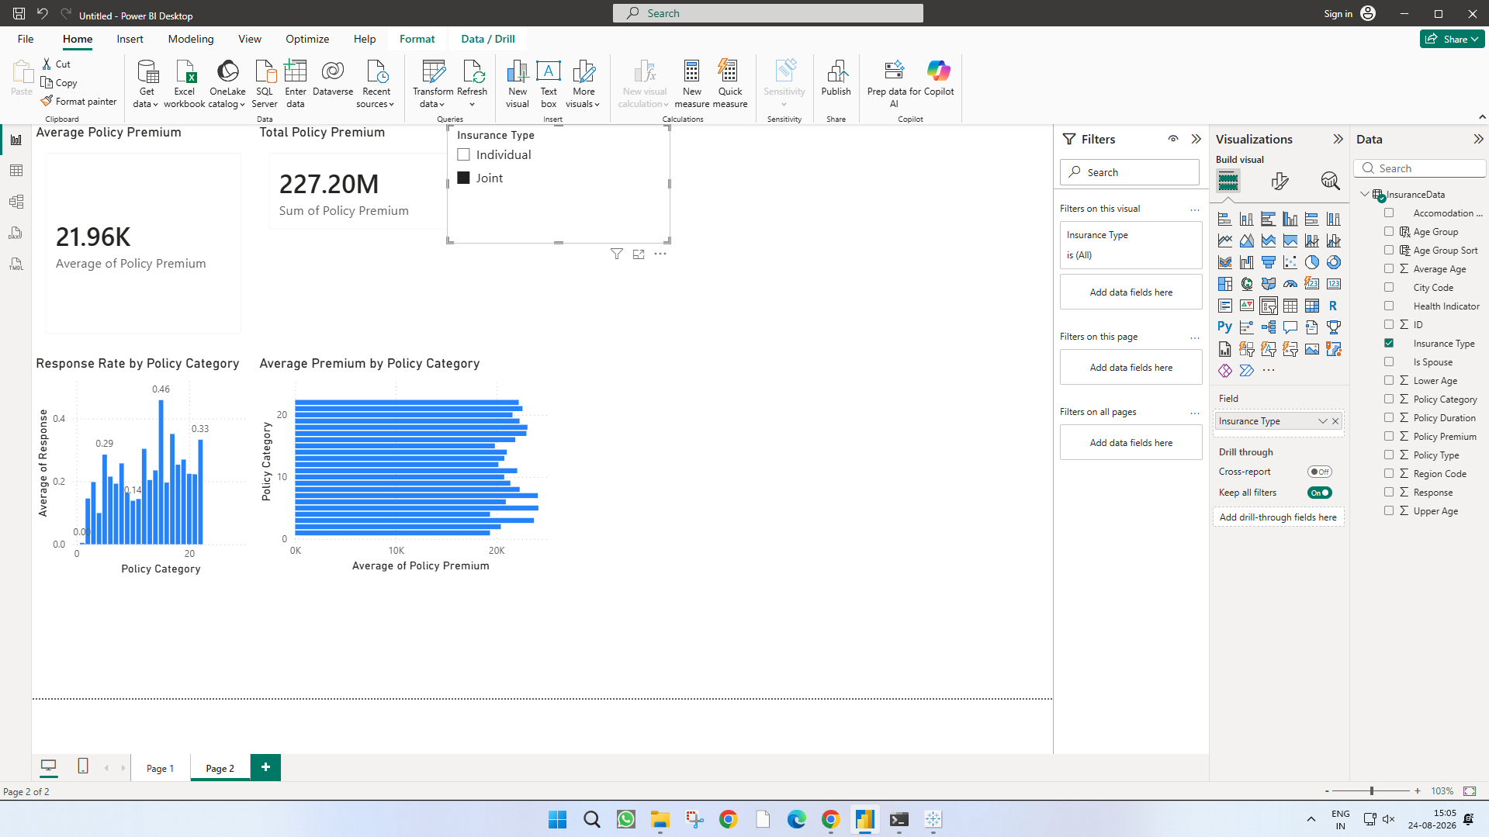

RESULT:
Thus, various visualization techniques such as Line Charts, Bar Charts, Pie Charts, Histograms, Scatter Plots, and Box Plots were successfully created using Matplotlib. The graphical representations helped in understanding trends, distributions, comparisons, and relationships within the dataset.

